Mini Project Report on

**E-Dabbawalla**

Submitted in partial fulfillment of the requirements of the degree of

Bachelor of Engineering in Computer Engineering

`

by

**SAISH SACHIN SANKHE ( 71 )**

**PRIYANSHU ROHIT SHARMA ( 72 )**

**ASHWINI DHRUVENDRA VIKRAM SINGH ( 73 )**

Supervisor:

**Prof. RESHMA CHAUDHARI**



**Computer Engineering Department**

**VIVA Institute of Technology**

**University of Mumbai**

**2021-2022**

**CERTIFICATE**

This is to certify that the project entitled **“E-Dabbawalla”** is a bonafide work of **“SAISH SANKHE, PRIYANSH SHARMA, ASHWINI SINGH”** submitted to the University of Mumbai in partial fulfillment of the requirement for the award of the degree of **“Bachelor of Engineering in Computer Engineering”**

Prof. Reshma Chaudhary

Supervisor/Guide

Prof. Ashwini Save Dr. Arun Kumar Head of Department Principal

**Mini Project Approval**

This project report entitled **E-Dabbawalla** by **SAISH SANKHE, PRIYANSH SHARMA, ASHWINI SINGH** is approved for the degree of **Bachelor of Engineering in Computer Engineering**.

Examiners

1. -------------------------------------------

2. -------------------------------------------

**Date:**

**Place**

**Abstract**

E-Dabbawalla is a website that allows the people to order a service that is inherently based on and is very similar to classic old Dabbawallas of the past, it also offers some advancement like better management, order organization, instantaneous booking, order diversity, etc. The Dabbawallas have been operating in India for many decades now, and since their inception they have operated purely on the basis of trust, discipline, order and a need to fulfil customers’ requirements. But now we have entered the age of Digitization and it is something that the Dabbawallas too can benefit from, so our purpose for this project is to make a website that can take care of the communication infrastructure, and make it more robust, reliable, responsive, adaptable and speedy. Doing such advancements will not only increase their profits but also save an industry that is currently on the brink of collapse, digitization is absolutely necessary for a business model of this kind in the current generation, if it wants to function at an efficiency similar to their competitors. Our methods include digitizing of the classic Dabbawalla model and allowing more people to access it with ease, we have constructed a website using HTML, CSS and a Database system. Our final results show an operational website with multiple food items to choose from and the ability to buy/book those food items for delivery. Conclusively we have achieved all of our goals and have successfully constructed a means for Dabbawallas to digitize their way of business, and harness the technology of the current generation.

i

i

**Table of Contents**

|  |  |  |  |  |
| --- | --- | --- | --- | --- |
| **Sr.**  **No.** | **Topics** | | | **Page No.** |
|  |  |  | **Abstract** | **i** |
|  |  |  | **List of Figures** | **iii** |
|  |  |  | **List of Tables** | **iii** |
| **1.** |  |  | **Introduction** | 1 |
| **2.** |  |  | **Literature Survey** | 2 |
|  | 2.1 |  | Survey Existing System | 2 |
|  | 2.2 |  | Limitation Existing System or research gap | 7 |
|  | 2.3 |  | Problem Statement and Objective | 7 |
|  | 2.4 |  | Scope | 8 |
| **3.** |  |  | **Project Description and Implementation** | 9 |
|  | 3.1 |  | Framework/Algorithm | 9 |
|  | 3.2 |  | Details of Hardware and Software | 9 |
|  | 3.3 |  | Design Details: UML& Class Diagrams | 10 |
|  | 3.4 |  | Results | 12 |
| **4.** |  |  | **Conclusions** | 15 |
|  |  |  | **References** | 16 |
|  |  |  | **Acknowledgement** |  |

ii

**List of Figures**

|  |  |  |
| --- | --- | --- |
| **Figure No.** | **Name of figure** | **Page. No.** |
| 3.1 | Flow of Proposed System | 9 |
| 3.12 | UML Diagram | 10 |
| 3.13 | Class Diagram | 11 |
| 3.2 | Home Page | 12 |
| 3.3 | Login and Sign-up page | 13 |
| 3.4 | Listing page | 13 |
| 3.5 | About us | 14 |
| 3.6 | Contact us page | 14 |

**List of Tables**

|  |  |  |
| --- | --- | --- |
| **Table No.** | **Name of Table** | **Page. No.** |
| 2.1 | Literature Survey Table | 5 |
|  |  |  |

iii

**Declaration**

We declare that this written submission represents our ideas in my own words and where others’ ideas or words have been included. We have adequately cited and referenced the original sources. We also declare that we have adhered to all principles of academic honesty and integrity and have not misrepresented or fabricated or falsified any idea/data/fact/source in my submission. We understand that any violation of the above will because for disciplinary action by the Institute and can also evoke penal action from the sources which have thus not been properly cited or from whom proper permission has not been taken when needed.

**SAISH SANKE**

**PRIYANSHU SHARMA**

**ASHWINI SINGH**

**Date:**

**Place:**

iv

**Chapter 1**

**Introduction**

The E-Dabbawalla is the Digitization of the services that the Dabbawallas provide using their classical methods, the Dabbawalla service has been reliant completely on the word passing and handwritten ledgers in order to communicate to and fro, between the chain of command and the client and the seller of the Dabba. This process, while being functional is quite slow and also an hinderance due to lack of adaptability and spontaneous change in delivery methods. The System that we have proposed will fix these issues with ease along with providing the Dabbawallas to be competitive against their current competition which are various food delivery services. Doing such advancements will not only increase their profits but also save an industry that is currently on the brink of collapse, digitization is absolutely necessary for a business model of this kind in the current generation, if it wants to function at an efficiency similar to their competitors. Our methods include digitizing of the classic Dabbawalla model and allowing more people to access it with ease, we have constructed a website using HTML, CSS and a Database system. Our final results show an operational website with multiple food items to choose from and the ability to buy/book those food items for delivery.

1

**Chapter 2**

**Literature Survey**

The following chapter is a literature survey of the previous research papers and researchers which gives information about the previous system along with the techniques used and future scope.

**2.1 Survey of Existing System**

**Paper 1:**

**Title:** Website design: Viewing the web as a cognitive landscape.

**Authors:** Mircea Petrache

**Theory:**

Web content has been identified as one of the main factors for repeated access. Content on the web includes text, images, Choosing the right web content is essential for effective web design, whether it's graphics, layout, sound, movement, or even the smell of one day, in the meantime, understanding marketing strategies to drive traffic to your website is beginning to grow and how to turn web surfers into repeaters. This is a phenomenon that is not well understood. Through empirical research, the author develops a Website Preference Scale (WSPS) based on: Environmental psychology work by Rachel Kaplan and Stephen Kaplan. Many factors of layout and picture artwork may be used to deliver content material at the web. The picks are simply endless. Elements of space, use of images, length of images, use of animation and/or audio, wide variety of phrases in line with line, and length of characters are amongst only a few of those factors. Additionally, the paintings of content material layout do now no longer prevent with choosing the ideal factors for the specific audience. Content layout additionally entails choosing the placement of these factors to facilitate their use. The results identify the basic aspects of an effective website Design website design features to provide insights. This can increase the chances of a return visit.

**Paper 2:**

**Title:** Online marketing strategies: The future is here.

**Authors:** Monika Grabowska, Susanne Schwarzl

**Theory:**

The traditional (offline) marketing strategy has already been widely used by companies around the world, and there is almost no new option for promoting competition. And here is almost unlimited possibility and optional marketing. In this paper, we focus on increasing the importance of online marketing, including prior art research by analysing data provided by many surveys. In addition, it includes a brief description of online marketing itself, a basic strategy on the recent internet. This paper contains 5 blocks. It first explores the key facts and numbers that explain at the cutting edge of online marketing and provides relevant insights to better understand its growing role. Our study was conducted using methods of analysis and synthesis of data provided by the CMO Council, WebDAM, iContact, ContentPLUS, and other sources. Next, the most important terms were explained to ensure a detailed and comprehensive coverage of the topic. Third, customer behavior is revealed in the consumer decision-making process. Fourth, various online marketing strategies are explained. One of the most important issues companies should focus on is customer behavior. To develop an effective 4484 marketing mix, segmentation, targeting, positioning, and marketing, you need to understand how your customers rate and make decisions about. Comprehensive knowledge of brand and consumer value not only develops products like, but also develops communication programs to position products and convince people to think about them the way companies prefer.

**Paper 3:**

**Title:** A Comparative Study of Unstructured Data with SQL and NO-SQL Database Management Systems

**Authors:** S.M.Aqil Burney

**Theory:**

This paper goals to set up a relative observe among a relational Microsoft SQL Server database and a non-relational MongoDB database in the unstructured illustration of statistics in JSON format. There is a notable quantity of labor finished concerning evaluation of a couple of database control programs on the premise in their performances, safety etc., however we've got confined records to be had wherein those databases are assessed on the premise of furnished statistics. This observe will particularly awareness on searching at all of the opportunities that each those database sorts provide us whilst dealing with statistics in JSON. The trouble we're provided with is to decide the extra powerful out of those database sorts (SQL or NO SQL) even as managing JSON, and what the case wherein they taken into consideration to be extra powerful than the other. The purpose is to gift the effects of the experiments; in addition to the comparative observe alongside with the situations wherein those effects have a more bearing. It is vital to behaviour a cautious evaluation and don't forget the principle elements among the pliancy of schema, the quantity of statistics, the range of resultant transactions and the price range as soon as choosing the statistics version for the application. We will accomplish this via way of means of enforcing a sequence of experiments even as thinking of that the subjected statistics does now no longer require to be normalized; and therefore, examine the final results to finish the result.

**Paper 4:**

**Title:** A Review of the Usable Food Delivery Apps

**Authors:** Rafi Ur Rahman

**Theory:**

This paper provides a general background for food delivery applications and the process of ordering food through food delivery applications. It is now assumed to be in the world of information technology. Today, people are accustomed to using computers, mobile phones and mobile applications. Method / Statistical Analysis: This study focused on all available meal ordering systems, whether manual or digital, and grouped them into different categories of food delivery apps. Next all categories are explained in detail. Since then, some commonly used applications have been evaluated. The technology used for these applications is then highlighted. Survey concludes that the use of digital applications in meal ordering systems has increased and is becoming more popular with customers. Applications / Improvements However, there are still some usability issues with the currently available food delivery applications. You need to develop mobile applications that strictly apply usability rules and guidelines. The online grocery delivery application is very suitable for those who do not have time to go to a restaurant. If you have a smartphone, you can easily order the Essentials from anywhere and deliver it to your home. You can pay by cash on delivery or credit card.

**Paper 5:**

**Title:** Inclusive growth by means of sustainable supply chains: A case study of the dabbawalas of Mumbai.

**Authors:** Babu George

**Theory:**

As India seems to be an important player of the global economy, it is important to understand some of its own business models that interact with the culture economy, and found a place in its development orbit. Of these, Mumbai's Dabbawallas is worth special mention. Dabbawallas forms a lunch and a return system that provides hot lunch at work in India and a hot lunch. Based on basic research and innovative literature, this paper focuses on the sustainability of your business model and provides the latest prospects for Dabbawalla business. Dabbawalla system performance is described using some aspects of sustainability. The basis of the competitive advantage of Dabbawalla’s business model represents a new phenomenon from the cultural logic of ecosystems. Currently, they are a decentralized, flat self-managed network organizational structure with approximately 5000 members / staff. In a three-tier structure, all employees are paid equally. Organizational culture is characterized by disciplinary action, not loyalty. This culture is known for promoting personalized customer care, joint planning, and implementation. They take pride in strong teamwork and strict time management. This case study of the dabbawallas main goal is to identify the bases of their competitive advantage from perspectives ranging from their historical roots continued community spirit, sustainability orientation, and the various conditions in the business that need to be fulfilled for a smooth and proficient operation.

**Analysis Table:**

|  |  |  |  |  |
| --- | --- | --- | --- | --- |
| **Title of paper** | **Summary** | **Advantages** | **Disadvantages** | **Open Challenges** |
| Paper Title 1 | This paper is about a review of Website design and Viewing the web as a cognitive landscape. | A Website Preference Scale (WSPS) based on: Environmental psychology work, can be used to learn about possible optimizations for the website. | Biggest Disadvantage is lack of diversity in the data set used to make the WSPS as different demographics has different needs . | Understanding marketing strategies to drive traffic to your website is beginning to grow and how to turn web surfers into repeaters. |
| Paper Title 2 | This paper is about Online marketing strategies and the ways to approach and implement the said strategies effectively.. | Show the Important approach to capture the attention of the customers first, then revealing detail to raise interest and then finally presenting them the option to participate in the offer. | The amount of work in data analysis has grown by a factor of many times this is due to the grown no of customers that can be targeted by advertisements. | . Data analysis of the captured data to understand the requirements of the customers so a high retention can be kept by fulfilling the said needs. |
| Paper Title 3 | This paper is a Comparative Study of Unstructured Data with SQL and NO-SQL Database Management Systems | It was found that the fastest one is MongoDB, generally faster by fifteen seconds more than the  SQL Server. | SQL database turned out to be slower by a significant margin. | To determine the more effective while dealing with JSON, and what  case were they considered to be more effective than the other |
| Paper Title 4 | This paper is about a Review of the Usable Food Delivery Apps | It was found that the problems present in the normal food ordering services can be solved effectively using current mobile communication infrastructure. | Development of the app needs special care as there is no human element while ordering which can adapt, any confusion created can’t be resolved immediately. | Introducing an attractive UI/UX design in order to retain the customer, and also simplify the ordering method as much as possible. |
| Paper Title 5 | This paper is about Work and Food Culture Of The Mumbai Dabbawallas and how they operate. | The paper shows an in-depth analysis how the Dabbawallas function. With their merits and the drawbacks in their functioning. | Dabbawallas have been in operation for very long time so there is a possibility that there are underlying functionalities which haven’t been explored yet. | Digitizing the communication, tracking, and payment processing of the Dabbawallas infrastructure. |

**2.2 Limitation Existing System**

The Existing system has several limitations that cause many people to not use it, currently we have observed that people do not like using the currently present communication system because it is too slow and has no adaptability to spontaneous change, along with that the current payment method is quite primitive for Dabbawallas, and even with the integration using UPI the lack of convenience still persists as there is way to order food while browsing various options and their details like in a website. There are also no backlinks to the dabbawalla’s business, hence its not possible to do effective online advertising using the business’s name on various websites, like Facebook, twitter, Instagram, google ads, etc

**2.3 Problem Statement and Objective**

The Dabbawallas have been operating in India for many decades now, and since their inception they have operated purely on the basis of trust, discipline, order and a need to fulfil customers’ requirements. But now we have entered the age of Digitization and it is something that the Dabbawallas aren’t benefiting from yet, and this is a lost opportunity to adapt with the changing times. Which can lead to a complete elimination of this industry if they do not act quickly, many food delivery networks are already leaving a mark on the food industry as they grow further, and capture more customers but these food delivery networks aren’t able to target the specific customer base that the Dabbawallas serve, this is due to many reasons but the biggest one is the cost of delivery and cost of the food of Dabbawallas being much more competitive. Thus the Dabbawallas have an opportunity today to capture the online customer base and recapture the customer base that has been lost due to the convenience of the new Food Delivery networks.

8

**2.4 Scope**

In this project, we have developed a website that allows the people to order a service that is inherently based on and is very similar to classic old dabbawallas of the past. In this we have made use of HTML, CSS for programming and used Visual Studio editor . This project is at very basic level . In future we can make it more and more advance . We can make this application helpful for the dabbawallas by adding the feature of digitizing the whole business which will ease the dabba ordering process. From Adding the feature of easy ordering process the users can get more help and time will be save. Suppose a person wants dabba for a week so, the user just have to create a account by simply entering the credentials , from the listing the user have to select the category accordingly i.e. veg, non-veg. Then, user just have to click on order now button and the order will be placed for a week so the user does not need to place order for seven time. In this project we have used database to store the user credentials and the order which will be placed by user . We have to make this application to work on large load and working efficiently .

**Chapter 3**

**Project Description and Implementation**

The following chapter gives the algorithm, design, framework and the implementation details of the proposed system.

**3.2 Details of Hardware and Software**

**3.2.1 Hardware**

The Hardware Interfaces includes:

* + - * 200GB Hard disk
      * 4 GB of RAM

**3.2.2 Software**

The Software Interfaces includes:

* + - * Visual Studio Code Editor
      * Web Browser

**3.3 Design Details**

**3.3.1 UML DIAGRAM**

The purpose of use case diagram is to capture the dynamic aspect of a system. However, this definition is too generic to describe the purpose, as other four diagrams (activity, sequence, collaboration, and State chart) also have the same purpose.

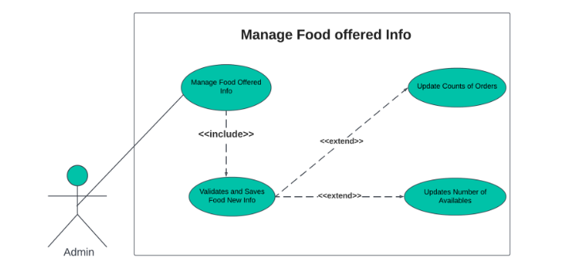

Fig. 3.12 UML Diagram

**3.3.2 CLASS DIAGRAM**

The class diagram describes the structure of a system by showing the system's classes, their attributes, operations, and the relationships among objects.

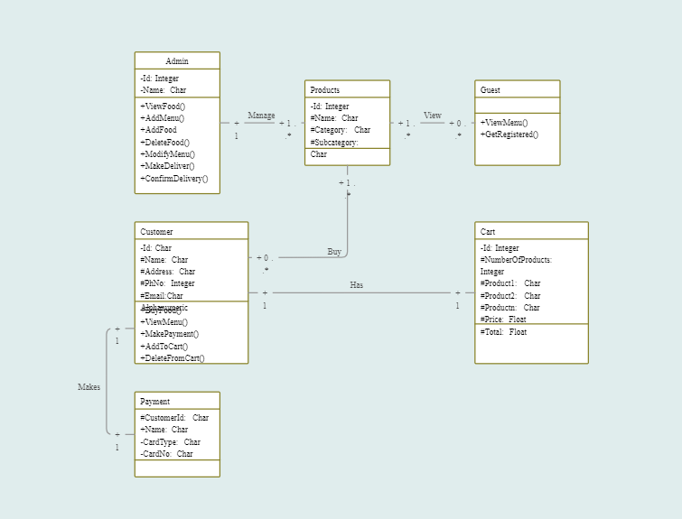

Fig. 3.13 Class Diagram

**3.4 Results**

The following are screenshots of different frames of the application. The Fig. 3.2 shows The first page of the website is the homepage which contains a variety of dishes, and foodstuffs for people to order, it also contains links to various pages such as about, contact us, orders, food items, etc.

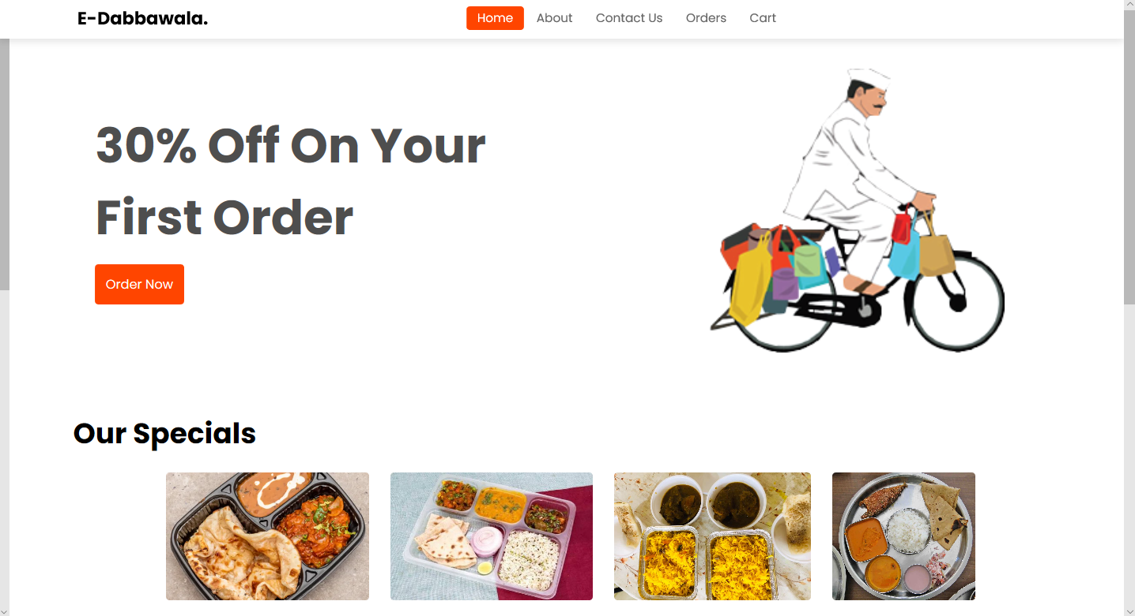

Fig. 3.2 Home Page

Next page created is for registration /signing up and login in. This would allow the first-time user to register using username and password, it would allow a registered user to login via this page as shown in the Fig. 3.3

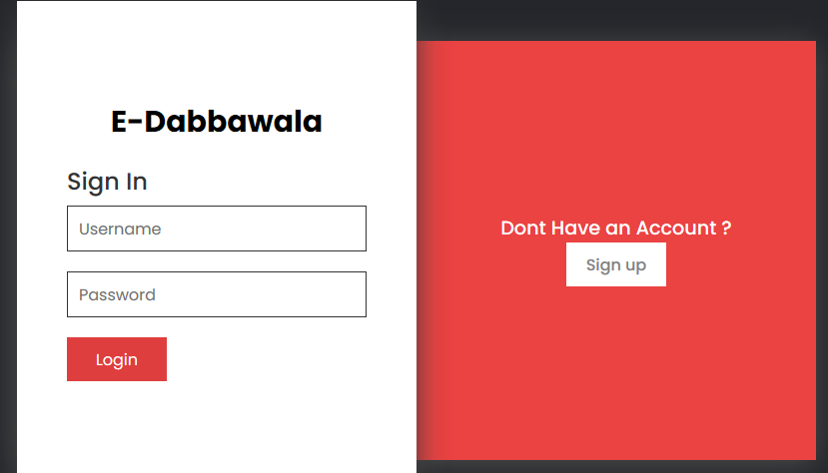

Fig. 3.3 Login and Sign up page

The next objective was to create listings in order to add various kinds of dishes and food stuffs for ordering. It would also include photographs of the mentioned dishes with their authentic name, some dishes that we have added are fish thali, veg thali, etc.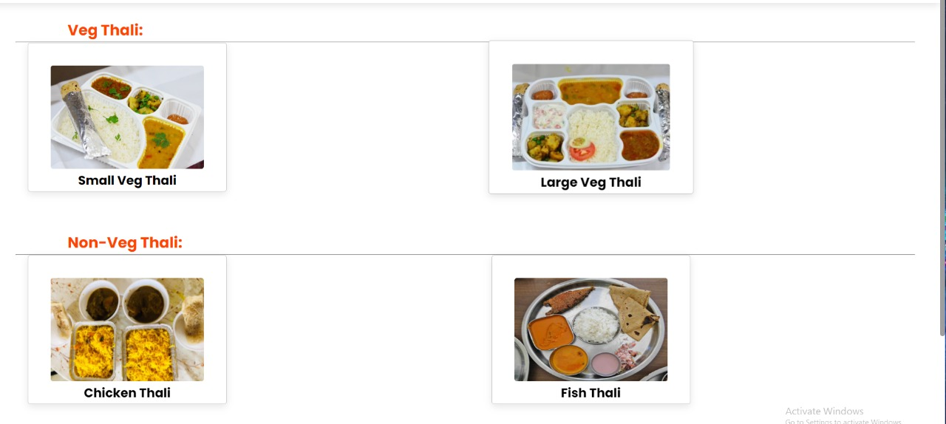

Fig. 3.4 Listing Page

Then other miscellaneous pages were created in order to make sure that the customer or the user accessing the website would have a clear and concise view of the site and all the information about it. As shown in the Fig. 3.5 and 3.6.

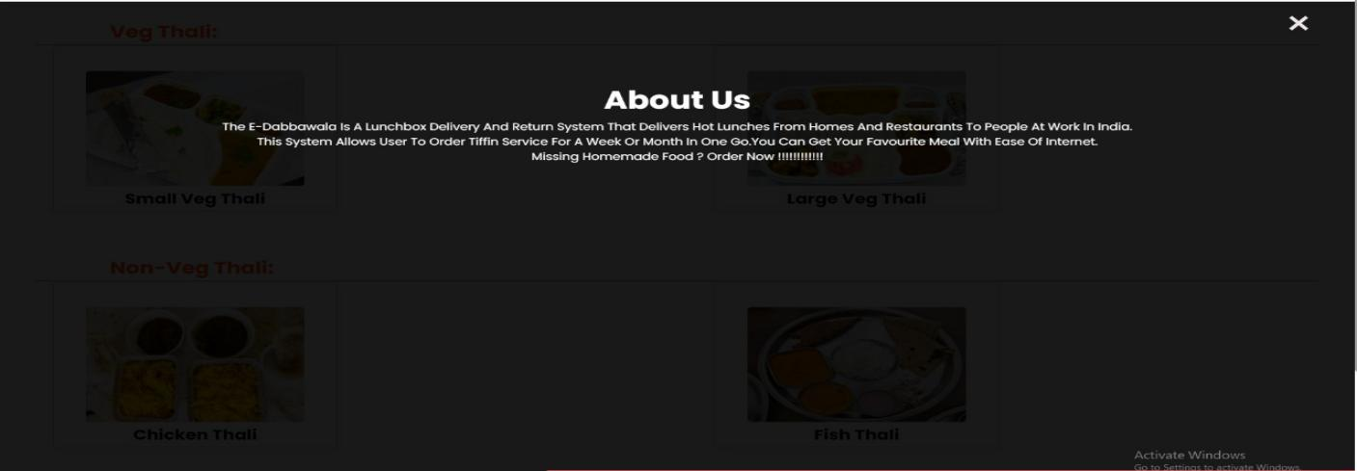

3.5 About Us page



3.6 Contact Us page

14

**Chapter 4**

**Conclusion**

To sum up everything that has been stated so far, we have discussed how the Dabbawalla’s have been falling behind in their sales due to the highly competitive online market. The Creation of E-Dabbawalla has allowed the dabbawalla service to have an online platform with all the connection being backlinked into the main website, hence now effective advertisement for dabbawalla service is possible in websites and apps like facebook, google, Instagram, twitter, online blogs, etc. The website provides a relatively fast version of ordering process, which makes the process of ordering much more enjoyable and easy to use. Our website has a responsive user interface which has no complexity thus allowing for all users to have an ease of access. Payment can be setup to be done online which makes the process much more convenient to use for a lot of people.

15

**References:**

1. [(PDF) Inclusive growth by means of sustainable supply chains: A case study of the dabbawalas of Mumbai.](https://www.researchgate.net/publication/329972198_Inclusive_growth_by_means_of_sustainable_supply_chains_A_case_study_of_the_dabbawalas_of_Mumbai)
2. [(PDF) A Comparative Study of Unstructured Data with SQL and NO-SQL Database Management Systems](https://www.researchgate.net/publication/340622952_A_Comparative_Study_of_Unstructured_Data_with_SQL_and_NO-SQL_Database_Management_Systems)
3. [(PDF) A WEB-BASED DATABASE SYSTEM: AN INDUSTRIAL APPLICATION](https://www.researchgate.net/publication/267394100_A_WEB-BASED_DATABASE_SYSTEM_AN_INDUSTRIAL_APPLICATION)
4. [(PDF) A Review of the Usable Food Delivery Apps](https://www.researchgate.net/publication/342118544_A_Review_of_the_Usable_Food_Delivery_Apps)
5. [(PDF) Online marketing strategies: The future is here](https://www.researchgate.net/publication/283800235_Online_marketing_strategies_The_future_is_here)
6. [s0148-2963_2802_2900353-320161207-15697-1ha03jv-with-cover-page-v2.pdf](https://d1wqtxts1xzle7.cloudfront.net/50776724/s0148-2963_2802_2900353-320161207-15697-1ha03jv-with-cover-page-v2.pdf?Expires=1649127609&Signature=B6r8LojKXGMCr00SmidE0Iiba6YwUHDBQDxi8EnJCNcxdRhd2R0x6YxWTRkcI7BDodopGxGxxmvbCIPE8A5jNITA019PD7dvehcJnOHucetxWCfsvLYTwVbdDbiO15Dt-CEohpYHds2-HeetXXl0Ku4soAo5tLvxGruHx-WvMeeaqY28tIOVKKgEMYUvjUek917Wsf~ex5Z2Zz3iI2y5L1zYD0ESUhJ4Bf7xyMeJGQ4i-gX0ZdjF39bJDgAdEm08CtKNkBh5hORj2A3ry-xGv2u3jS3Qw47bVlXwmrRgmX9MwCsh9JiT-AfYYEma3-5GeozIAhQRknIFcZH3DGVolg__&Key-Pair-Id=APKAJLOHF5GGSLRBV4ZA)
7. <https://www.w3schools.com/>
8. <https://stackoverflow.com/>

**Acknowledgement**

We would like to express a deep sense of gratitude towards our guide Prof. Reshma Chaudhari, Computer Engineering Department for her/his/their constant encouragement and valuable suggestions. The work that we are able to present is possible because of her/his timely guidance.

We would like to thank Head of the Computer Engineering Department, Prof. Ashwini Save for her support and co-ordination.

We are also grateful to teaching and non-teaching staff of Computer Engineering Department who lend their helping hands in providing continuous support.

**SAISH SANKE**

**PRIYANSHU SHARMA**

**ASHWINI SINGH**